Manual execution

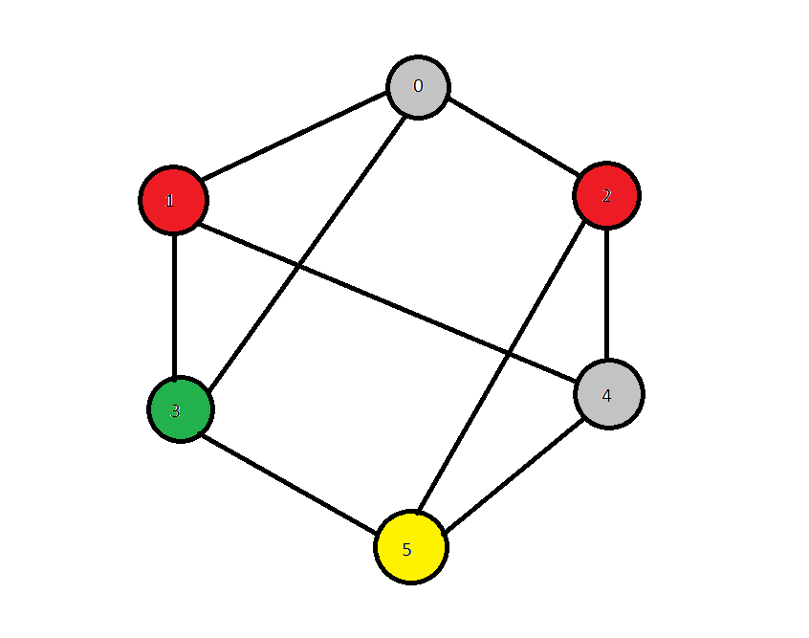

Input file:

6 9
0 1 0
0 2 0
0 3 0
1 3 0
1 4 0
2 4 0
2 5 0
3 5 0
4 5 0

Iteration | Edge | Highest color | Colors
Initialization | [] | 0 | 0 1 2 3 4 5
Initialization | [] | 0 | 0 0 0 0 0 0
1 | [0,1] | 1 | 0 1 2 3 4 5
1 | [0,1] | 1 | 0 1 0 0 0 0
2 | [0,2] | 1 | 0 1 2 3 4 5
2 | [0,2] | 1 | 0 1 1 0 0 0
3 | [0,3] | 2 | 0 1 2 3 4 5
3 | [0,3] | 2 | 0 1 1 2 0 0
4 | [1,3] | 2 | 0 1 2 3 4 5
4 | [1,3] | 2 | 0 1 1 2 0 0
5 | [1,4] | 2 | 0 1 2 3 4 5
5 | [1,4] | 2 | 0 1 1 2 0 0
6 | [2,4] | 2 | 0 1 2 3 4 5
6 | [2,4] | 2 | 0 1 1 2 0 0
7 | [2,5] | 2 | 0 1 2 3 4 5
7 | [2,5] | 2 | 0 1 1 2 0 0
8 | [3,5] | 2 | 0 1 2 3 4 5
8 | [3,5] | 2 | 0 1 1 2 0 0
9 | [4,5] | 3 | 0 1 2 3 4 5
9 | [4,5] | 3 | 0 1 1 2 0 3

Vertex 0 has color 0
Vertex 1 has color 1
Vertex 2 has color 1
Vertex 3 has color 2
Vertex 4 has color 0
Vertex 5 has color 3

